Name:___________________________________ Date:_________________________ Band:________
Calculus | Packer Collegiate InstituteTinkering: An Introduction to the Idea of Optimization

The Parking Lot: In our last class, we started encountering the idea of absolute maximums and absolute minimums. These are important concepts! We often want to find the best of something given some constraints. For now, let’s tinker, you thinker!
To start our day of puzzles, go to this parking lot in beautiful Elizabeth, New Jersey.
http://www.gmap-pedometer.com/?r=5320146
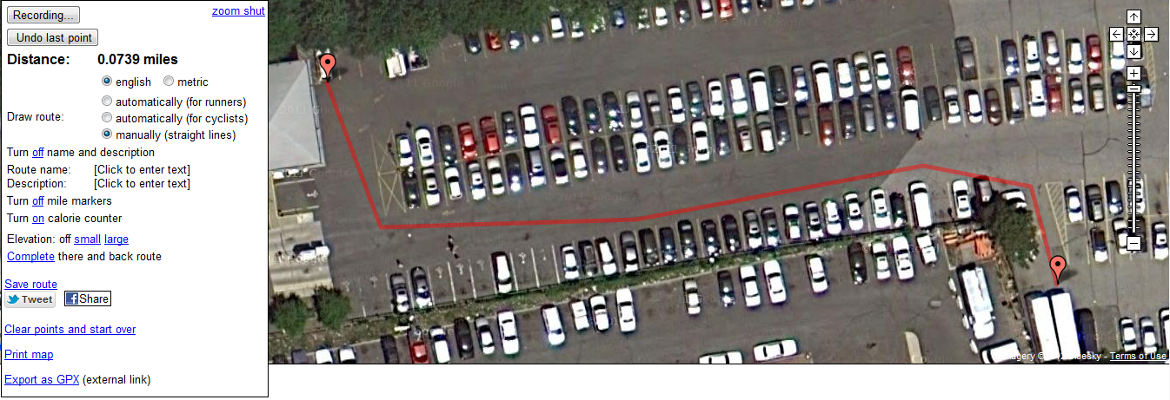
Notice that we made a route that travels from the car in the back left corner to the 2nd truck in the front right corner. I found out that that distance was 0.0739 miles.
We want to minimize the distance we’re traveling – but we can’t travel in a straight line.
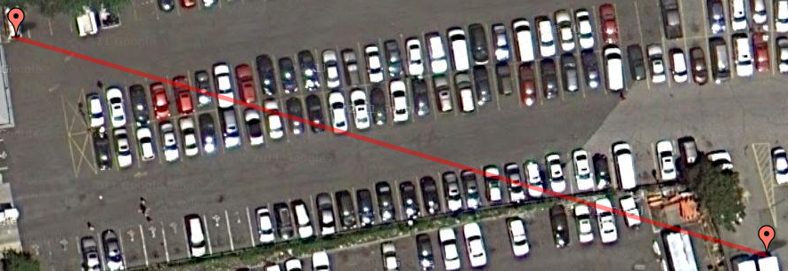
Why not? What’s the problem with this route?
____________________________________________________________________________________________________________________
So we want to minimize the distance we’re traveling, but we have some constraints!
Note: You may pass in between cars, just so long as the line does not touch any cars.

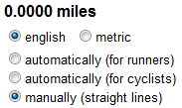
So see if you can find a route that is as minimal a distance as possible. To do so:
- Click “Clear Points at Start All Over”
- Make sure you have the same settings as I do (English, manually)
- Click “Start Recording”
- Double click on the black part of the trunk of the car in the back left
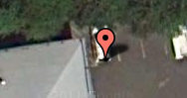
- Now make a path. Double click where you want to place the next marker, single click and drag to shift the screen around.
- You have to end up with your last marker on the black part of the second truck in the front right
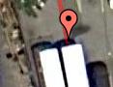
Find three routes, trying to minimize your distance. For each route, record the distance, and then click “Save your Route” and then “Save as Public” and write down the URL below:
miles
and the URL is: http://www.gmap-pedometer.com/?r=
and the URL is: http://www.gmap-pedometer.com/?r=
miles
and the URL is: http://www.gmap-pedometer.com/?r=
miles


Boxes: Now we’re going to have you tinker with boxes. You might have done this in Algebra II or Precalculus. But instead of using math, I want you to use your brains.
You have a piece of graph paper in front of you. Carefully cut it into rectangle which has 20 units on one side and 30 units on the other.
If you cut out a square from each corner, and fold up the sides, you’ll get a box with no top.
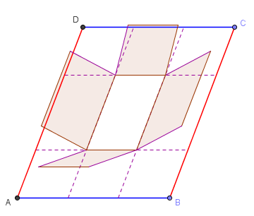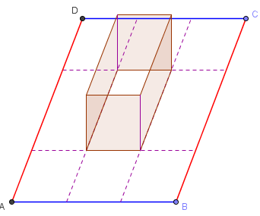
So without doing any calculations, try your best to decide how big a square to chop off from the four corners to maximize your box’s volume. Create your box (tape the edges together), and record the volume below. Write your name in the bottom of the box.
Length (in graph paper units):
Width (in graph paper units):
Height (in graph paper units):
Volume:


The Saddest Number: How should two nonnegative numbers be chosen so that their sum is 1 and the sum of their squares is:
(a) as large as possible
(b) as small as possible

Making generalizations:

For each problem, what are you trying to maximize or minimize?
Parking Lot:
Boxes:
Saddest Number:

For each problem, what is the constraint that limits what your maximum/minimum is?
Parking Lot:
Boxes:
Saddest Number:

The main mathematical take-away for this worksheet, for me, is:

