Name:_______________________ Date assigned:______________ Band:________
Precalculus | Packer Collegiate Institute
Counting!
Today we’re going to start learning how to count. Like, yeah, you already know how to count. 1, 2, 3, 4, 5, … Duh. But we’re going to come up with shortcuts to counting things. Like, counting without counting. WHAAA? Let me illustrate.
How many lightning bolts are there? _____

How many lightning bolts are there? _____

Okay so the way you solved both problems were different. And clearly the second way was way faster. What we’re going to do is to learn to count without counting.
1. A quick question: A totally made up fact: there were only four different types of dinosaurs: the Iguanodon, the Juravenator, the Allosaurus, and the Gigantosaurus. Each dinosaur came in one of three colors: red, purple, and blue. The Museum of Natural History wants to have a model of each different-looking dinosaur. How many different models does the museum need to create? And more importantly: somehow convince me that your response is correct.

2. Another quick question: There is one more additional piece of made-up fact for you to consider. Each dinosaur had one, two, three, four, or even five claws. With this additional piece of information, how many different models does the museum need to create? And more importantly: somehow convince me that your response is correct.

3 (a). Ms. Tramontin gives you a multiple choice vocabulary test written in Azerbaijani.
Gecə göyün rəngi var: ___  A. Mavi  B. Yaşıl  C. Qırmızı  D. Qara  E. Sarı | 2 +3 = ____  A. altı  B. beş  C. sıfır  D. on doqquz | Okean edilir:____  A. konfet  B. su  C. pul  D. karandaşlar
How many different possible tests responses could she get back? Explain!

(b) Ms. Tramontin gives you a fill-in-the-blank vocabulary test written in Estonian. She puts more words in the wordbank than can be used – however no word in the wordbank is used more than once.
Fill in the blanks:
Koer läks ___________. Oli ____________ in puud. ____________ Lehmad olid lähedal. Samuti oli ____________.

Word bank:
kakskümmend metsa viima ahvide tiik magama

How many different possible tests responses could she get back? Explain!

(c). Ms. Tramontin gives you a fill-in-the-blank vocabulary test written in Estonian. She puts more words in the wordbank than can be used – however the words in the wordbank can be used once, twice, thrice, or even four times!
Fill in the blanks:
Koer läks ___________. Oli ____________ in puud. ____________ Lehmad olid lähedal. Samuti oli ____________.

Word bank:
kakskümmend metsa viima ahvide tiik magama

How many different possible tests responses could she get back? Explain!

(d) Now compare your answers to (b) and (c). Is it significantly better for you as a student to know you can’t repeat words, moderately better, or just slightly better? Justify your answer. If you can come up with a way to mathematically express how much better, do that!

4. (a) You are using the URL shortener bit.ly. What it does is it takes a URL like http://www.youtube.com/watch?v=G-OVrI9x8Zs and converts it to something smaller and slightly less ugly like http://bit.ly/TpCmH3. Each bit.ly link has a six characters, which include only the letters of the alphabet (and are case sensitive!) and numbers! So bit.ly/TpCmH3 is different than bit.ly/TpCmh3).
According to http://bit.ly/QtaFQK, on August 28, 2012, there were about 8.2 billion different webpages out there in Internet land. Could bit.ly assign each webpage a unique webaddress?

(b) QR codes are similar to URL shorteners, except instead of generating a shorter URL, the URL is encoded in a picture:

The way this works is slightly more complicated than I’m letting on, but in essence, except for four weird square shapes, each of the small squares are colored either black or white. And so there are a ton of QR codes that can be generated. (In reality, there is some awesome error correction that goes on, where things can be slightly off and it will still encode the right webpage.) For now, assume different QR code images correspond to different URLs.
If you subtract out the four “big squares” (three in the corners, one near a corner) which are used for a camera to position the QR code), there are 872 tiny squares remaining which are each colored black or white. How many different QR codes can be generated?

(c) Which can encode more URLs: bit.ly or QR codes?

5. New Scrabble game. You play first. You have the following seven scrabble letters. You have a computer at your disposal which will create a list all possible arrangements of those letters, whether they are words or not. You will then look through this output to help you! Can you figure out how many different arrangements the computer will list? (And while you’re at it, what’s the best word you can come up with?)
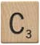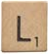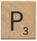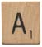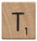

6. (a) You have the following Scrabble tiles. But you aren’t playing Scrabble anymore. Instead, you decide you want to find out how many different four letter arrangements can you can create (they don’t have to be words… so EBEP works!).
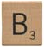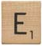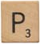
So… how many?

(b) How many different three letter arrangements can you create?
(c) How many different two letter arrangements can you create?

(d) How many different one letter arrangements can you create?

(e) We’ll go over this in more detail later (promise) but do you see anything different between Problem 7 and Problem 8a? Can you use the same method/reasoning to solve both?

7. (a) How many seconds are in a century (assuming no leap years)?

(b) You are taking a 25 question high-energy particle physics test with 6 choices for each question, and you know nothing about high-energy particle physics. Eep! Scary! How many different ways could you fill in the test? Then write down if that result surprises you, or if it was expected.

8 (a). Applebees currently has a promotion called . The deal has you choose two items from their “Simmering Soups” menu, their “Sensational Salads” menu, and their “Sandwiches and Pasta” menu – and you only pay $6.99! You can’t order two things from the same menu (so you can’t get two soups). You love everything Applebees! You want to go everyday until you try every possible combination. How many days in a row are you going to Applebees? [https://vimeo.com/44314536] Justify your response by explaining why you are doing what you’re doing.
 |  | 
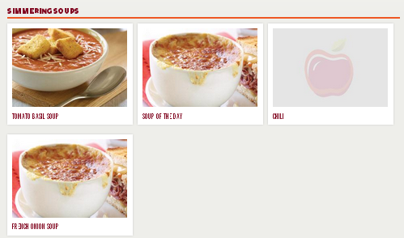 | 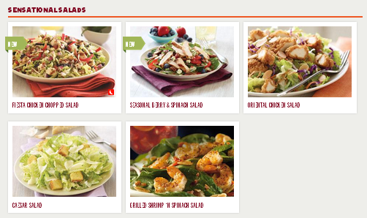 | 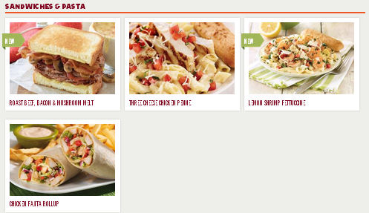

(b) Applebees decides if you want to get two soups, you should be allowed to. In fact, you are allowed to get two of the same soup! (Similarly for the other menus!) Now how many days in a row are you going to Applebees? Is it a lot different than in the previous scenario?

9. Mozart’s Musikalisches Würfelspiel (Mozart’s Dice Game)
A minuet is a highly stylized piece of music in ¾ time. Mozart, in his infinite pianoforte wisdom, created a little “game” where you roll a pair of dice, add them together, and they define a musical measure to be played in the minuet. You do this 16 times, to get the 16 measures.
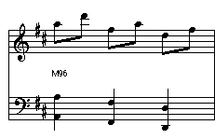
Assume for the first measure you roll a 2. You look on a chart that tells you what to play, and you’d play that measure. In this case the chart would read:

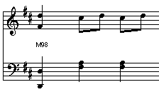
If on the other hand, you rolled at 10 for the first measure, you look at the chart that tells you what to play. In this case, the chart would read and you’d play this measure:

A sample chart is below. Even though I’ve only placed 8 measures in there, assume your teacher had the patience to paste all the measures in there – so every cell is filled with a measure of music!
 | measure  1 | measure  2 | measure  3 | measure  4 | measure  5 | measure  6 | measure  7 | measure  8 | measure  9 | measure  10 | measure  11 | measure  12 | measure  14 | measure  15 | measure  16
dice sum  2 | 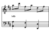
dice sum  3 |  |  |  |  |  |  |  |  | 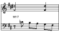
dice sum  4 |  |  |  |  |  |  |  |  |  | 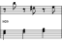
dice sum
5
dice sum  6 |  |  | 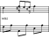 |  |  |  |  |  |  |  |  |  |  |  | 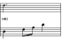
dice sum  7 |  |  |  |  |  | 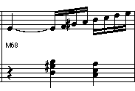
dice sum
8
dice sum
9
dice sum  10 | 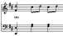
dice sum
11
dice sum  12 |  |  |  |  |  |  |  |  |  |  |  |  | 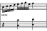

Roll two dice 16 times and record your sums:
measure  1 | measure  2 | measure  3 | measure  4 | measure  5 | measure  6 | measure  7 | measure  8 | measure  9 | measure  10 | measure  11 | measure  12 | measure  13 | measure  14 | measure  15 | Measure  16

Go to http://bit.ly/mozartdicegame and enter your results. Ignore measures 17-32 (that’s for the trio that comes after the minuet, which we shan’t concern ourselves with) and listen to your composition (click on “Play some Music.” You can generate the score sheet for your piece too! You just (kinda) composed a minuet! (With a little help from Mozart.)

- Before doing any calculations, estimate how many different minuets that Mozart can generate with his little dice game. Like, just write a number estimation below. No one will look at this – but write all digits of your number out (no exponent notation).
My estimation is:
- Try to figure out mathematically how many different minuets Mozart can generate. Do not only get your answer, but explain in words (and possibly diagrams/charts) how you got your answer.

- If Mozart was a super fast writer, with his quill and all, and could script out a minuet every minute (see what I did there? Anagrams! Scrabble!), how long would it take him to write out all the different possible minuets? Write your answer in the most appropriate units (is an answer in seconds better, or is it better to give your answer in years? Or something bigger?).

- You’re tossing dice, which is random. Are you equally likely to get every single one of the minuets, or are some minuets more likely to pop up than others? Explain how you’re thinking of your answer.

The best word can be found here: http://bit.ly/NoozzQ
http://www.applebees.com/menu/pick-n-pair (accessed 10 August 2012)

