NAME | Date | Band
Abstract Functions #1.9375
Calculus | Packer Collegiate institute

- Below is an area function. Draw a reasonable original graph that gives rise to this area function. Be sure to include the A, B, C, D, E, F, G in your graphs – so we can see where the behavior changes.
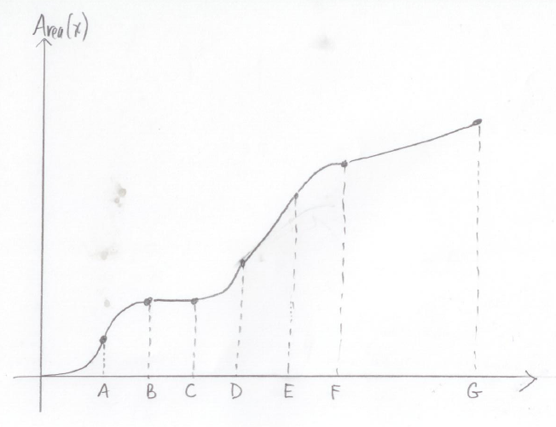

- Explain as clearly as you can why you drew your original function between E and F the way you drew it.

