NAME | Date | Band
Exploring Mathematics!
Adv Precalculus | Packer Collegiate institute

Here’s the thing. You guys actually find math fascinating. I find math fascinating. I want you to have fun exploring math that isn’t really tied to the curriculum. I want you to enjoy learning about something mathematical that piques your interest.

There are so many ways to find interesting mathematics.

  Read an article about mathematics or a mathematician in the New York Times. Submit a serious comment that cogently expresses your thoughts about the article. Print out the article and your comment you submitted. | 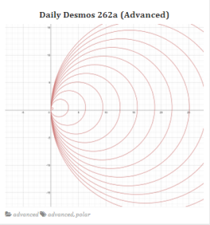  Visit Daily Desmos and find a graph that intrigues you. They are categorized into basic and advanced. Now try to reproduce that graph using Desmos.com (an incredible, incredible easy-to-use online graphing calculator). Submit a comment with your answer – or the closest you could get to your answer. Print out the original Daily Desmos challenge, and your Desmos.com page with your investigation to submit.
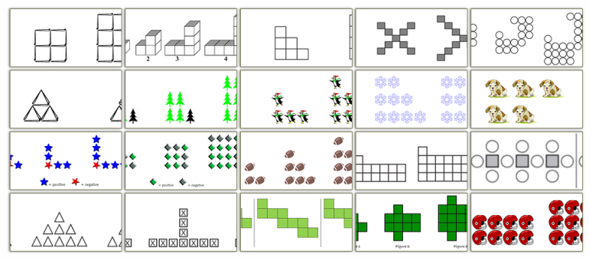  Do you like finding patterns? Did you find sequences interesting? Well if so, go to Visual Patterns and pick one of the hundred patterns, and try to determine the number of objects in the 43rd figure. Submit your answer. Print out the visual pattern you were trying to solve, and a brief writeup of your logic of how you tried to find the 43rd figure. It’s okay if you aren’t right! | 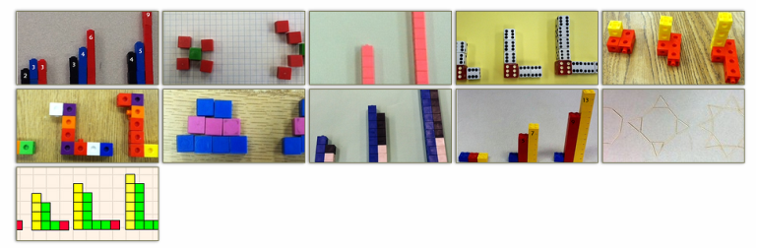  Do you like creating things? Go to Visual Patterns, visit the gallery to see what other students came up with, and generate your own puzzle (you can take a photograph of it). Submit your puzzle and the writeup of your solution.
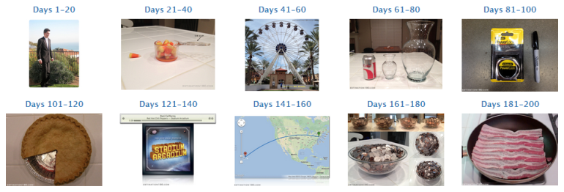  Do you like estimating how many jelly beans are in a jar? Go to Estimation 180 and pick three consecutive days of estimation challenges and take the challenge. After you submit your estimate, be sure to look at other estimates. Look at the answer. Print out the challenges, and write up three rationales as to how you came up with your three estimations, and also make sure to mention to true answer. It’s okay if you aren’t close to being right. |   “How many unique English tweets are possible? How long would it take for the population of the world to read them all out loud?” If you like hypotheticals, go to xkcd’s what if archives and find a hypothetical that interests you and has some math involved.  Print out the what if you were intrigued by, rewrite the “solution” in your own words -- additionally being sure to explain what drew you to the hypothetical, what you found innovative/interesting about the solution, and what you were confused by in the solution.
  New York City is the home to the newly creation Museum of Math (MOMATH). Visit this museum! Submit a review of the museum. If you can, include a photograph for your review.  Alternatively, every so often the Museum has lectures for the public – called “Math Encounters.” Attend one of them, and write a review of the lecture you attended. (These fill up quickly, so register early if you want to go!) | 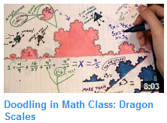  Go to Vi Hart’s youtube page and find a video that sparks your imagination. Watch it. Submit a serious comment that cogently expresses your thoughts about the video – what you liked about it, what confused you about it, what inspired you about it. Print out the article and your comment.
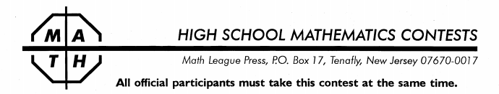  Packer regularly offers a 30 minute, 6 question contest called the New York Math League. Take one of these contests! | 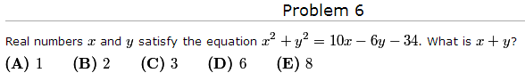  Packer is offering the American Mathematics Competition on Wednesday, February 19th after school. Take the AMC then.  If you are not able to take the AMC then, you can also get a blank copy of the test from Mr. Shah after the competition and solve any 3 problems that interest you (excluding problems #1-8). Submit your solutions
  One vibrant online community is the math stack exchange: “a question and answer site for people studying math at any level and professionals in related fields.” It has a number of higher level math questions, but you can find high-school level questions too.  Go to this site and find an interesting question and some answers for it. (Frequently asked questions might be of interest.) Submit the problem, the answers, and a short description of what you understand about the problem and the solution.  Alternatively, if there is a question about mathematics that you’ve been wondering but never understood (e.g. what does 0⁰ mean, really?), post it and see if someone responds. Submit your question, and any responses you get (if any). |   Math Munch is a ridiculously addictive weekly digest of the mathematical interesting on the internet. Go to the website and browse the archives. There are a number of things that will have you DO, MAKE, WATCH, READ, and PLAY. Find something that interests you.  DO: work on a puzzle, or solve a problem, or struggle with a problem  MAKE: re-create a piece of math art, or create your own artwork inspired by the original work  WATCH: watch a video and leave a comment on the site with what you learned and/or what questions you have  READ: read about a mathematician, write down why this mathematician was interesting to you, and compose two questions you’d like to ask this person  PLAY: play a math video game and then write a critique of it (likes, dislikes, suggestions, etc.)  For each of these, print out the original post and include your work (your solution, art, comment, critique, etc.)
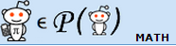  Are you a Redditor or simply love browsing Reddit? Visit the math subreddit. Find a thread that interests you. Submit a printout the thread and comments, and an explanation of why the thread was interesting, what you took away from it, and what questions you are left with. | Do you have some other mathematical thing you’re interested in doing… or that you’re already doing? Do you have a math problem you’ve invented and are working on? Are you reading a book about a mathematician/mathematics? Do you want to research RSA encryption because you find it interesting? Great! It can count too!  Just talk with me and I’ll let you know how it can be part of this!

The point of this is to allow you to explore mathematics that you are interested in exploring.
I want you to enjoy this.
You’ll notice the tasks are not designed to be challenging. That isn’t the point of this.
And I want to reward you for doing math for fun.
So this is what we’re doing…

The Task:
By the end of the third quarter, you will do five of these explorations. So you can be exposed to a variety of things, you should try to do five different explorations. However if there is something that you simply get obsessed with (e.g. watching Vi Hart videos) and want to do more of, just talk with me. It shouldn’t be a problem.
You should turn in at least three of the explorations by Monday, February 24th. You can turn in more, of course, if you get on a roll!
You should have all five of the explorations turned in by Friday, March 14th (pi day!).
As the quarter continues, I may ask you to present an exploration you found interesting to the class. So we can hear from a number of students, you will be (strictly) limited to two minutes.
Grading:
In terms of grading, these explorations are worth a total of 20 points – in other words, it is worth a small assessment. You can earn up to 4 points for each exploration, and you will earn an additional 4 points for submitting your favorite exploration to Intersections.
If you do the exploration and do a minimal job on it, you’ll get 2 points for it. If you do a solid job on it, you’ll get 3 points for it. If you do an excellent job, you’ll get 4 points for it. If you do a super-duper-excellent job on it, you will earn 4.5 points for it (extra credit!).
Additionally, you are expected to turn one of your explorations into a submission to Packer’s math-science journal Intersections by Friday, March 14th. If you submit your exploration on time and following the submission instructions properly, you will earn 4 points.
(Lateness will be penalized 1 point per day.)
Exploration #1 | Exploration #2 | Exploration #3 | Exploration #4 | Exploration #5 | Intersections

