NAME | Date | Band
A Conjecture about Semi-Circles, Part II
Adv Geometry | Packer Collegiate institute

On the very first day of class, we started making conjectures. We did the paper folding activity and saw we always got a right angle no matter how we folded the paper—which we were able to deductively prove. And then we played around with the following – which we were not able to deductively prove.
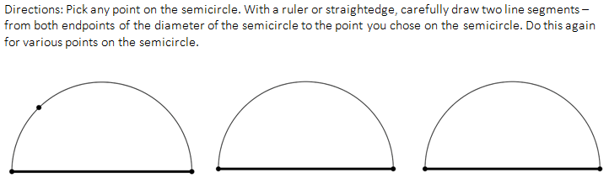
The conjecture was: no matter which point on the semicircle you chose, the angle formed by connecting a diameter’s endpoint to the point you choice to the diameter’s other end point would always be 90 degrees.
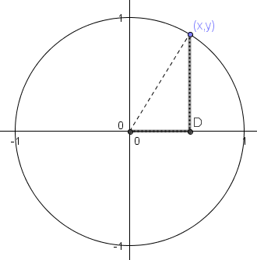
Believe it or now, you’re now easily able to prove this. We’re going to prove it in two different ways: Geometrically and Algebraically.
To prime us for the algebraic proof, we need to remember the equation for a circle with radius 1, centered at the origin. A diagram and a helpful triangle is there, in case you forgot the equation…

Equation: _______________________________________
Rewrite this equation by “solving for y” (meaning: rearrange the equation until you get y=blahblahblah):
Geometric Proof: For the five diagrams below, find the measure of the missing angle. Then draw in the sixth diagram which will prove our conjecture.
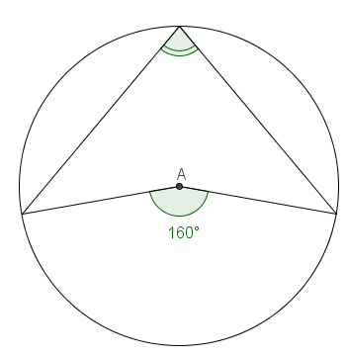 | 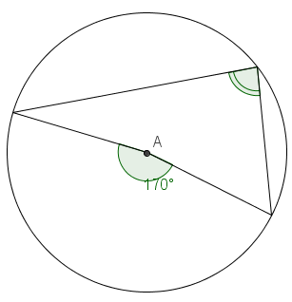 | 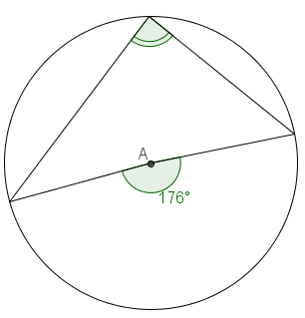
 | 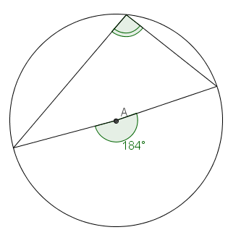 | 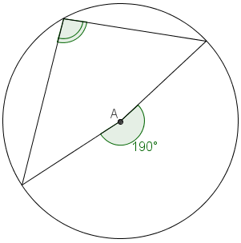

Write the theorem that we’re using: ____________________________________________________________
__________________________________________________________________________________________
_________________________________________________________________________________________.

Algebraic Proof:
Write down the equation for the top half of a circle with radius 1 centered at the origin: ___________________
Do you understand what this means? Let’s see: if x=0, what is y? __________
if x=0.2, what is y? __________
if x= - 0.7, what is y? __________
Let x simply be “x”. What is y? __________
Let point A be a random point on the semicircle, with an x-coordinate of x. Thus, A=( __________, __________).
On the diagram below, write these coordinates next to point A.
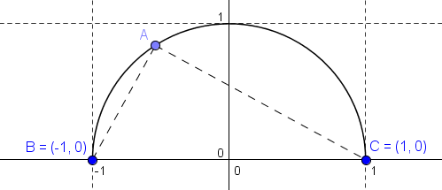
We want to show that angle BAC is 90 degrees for any point A.
In order to do that, what do we need to show about the slope of BA and the slope of AC?

Slope of BA: Slope of AC:

_____________________ of Slope BA:

