NAME | Date | Band
Similar Right Triangles #1: The Forwards Questions
Adv Geometry | Packer Collegiate institute
You’ve learned about similarity. You’ve learned about right triangles. This unit is a mashup of the two. In your physics classes, you may have learned about sine, cosine, tangent. But for now, we want you to forget what you’ve learned. Although we’ll come back to those ideas, we don’t want that getting in the way of what we’re about to do.
I, _________________________________, solemnly swear that I am going to try to forget everything I learned about sine, cosine, and tangent from physics class… at least for the time being… when I’m in geometry.
_________________________ _______________
Signature Date

- We know similarity is – informally – the “blowing up” or “shrinking” of a figure. Two figures which are similar look alike, but they can be different sizes. If you have two right triangles, what is the minimal amount of additional information that you could know which would show the two triangles are similar?
- (a) Draw a right triangle below, quickly. Use a straightedge and protractor.
(b) According to Plato, the ancient Greek philosopher, this is not a right triangle. This is not even a triangle. And he’s 100% right! A right triangle has a 90 degree angle. Is your angle perfectly 90 degrees? Maybe it’s 90.002 degrees? But even more philosophical, triangle is made up of line segments. And if you look at your pencil or pen mark super closely (or even with a magnifying glass or microscope), you’ll see it looks nothing like a line. It has some width – while a true line is made up of infinitesimally small points (which have no width). In fact, the lead on the paper even has some height coming off of the paper (see image of a pencil line magnified by an electron microscope below)
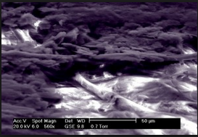

Yes, Plato is right. We’ve been drawing triangles, or see triangles printed on paper, and calling them triangles. But they aren’t. Not quite. The truth is: we can’t ever draw a perfect triangle. And the triangles we draw on Geogebra are composed of pixilated – not infinitesimal small lines. In a very real sense, triangles don’t exist in our physical world. But they do exist. We draw triangles, and we know they aren’t “true” or “perfect” triangles… but they are representations of an ideal triangle. This ideal triangle makes sense to us; it exists in our minds. It is a cerebral construct. Triangles exist not in physical reality, but in mathematical reality. There is an ideal understanding of “triangle” which we can never really see or have access to, but we know it exists! Paul Lockhart, who we read before, also wrote of this idea:
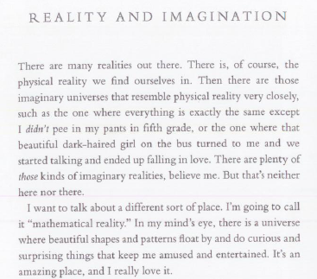
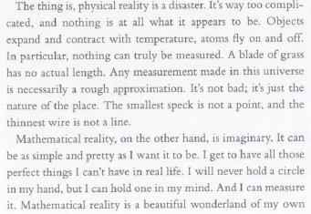
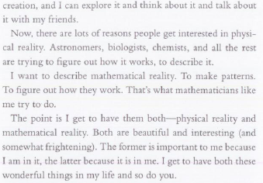
(Excerpted from Measurement by Paul Lockhart)
Do you think the number “5” has physical reality, or only a mathematical reality? What about the number “5/2”? What about “”? What about a circle? A point?
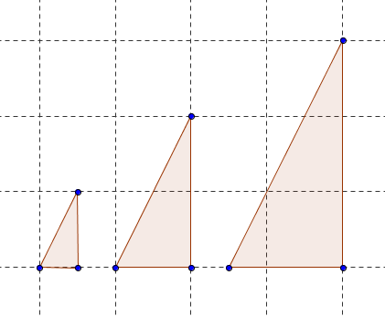
(c) For the next couple weeks, we are going to live in this world of forms, this mathematical reality. And we’re going to do it specifically with right triangles. We know the following groups of triangles are all similar:
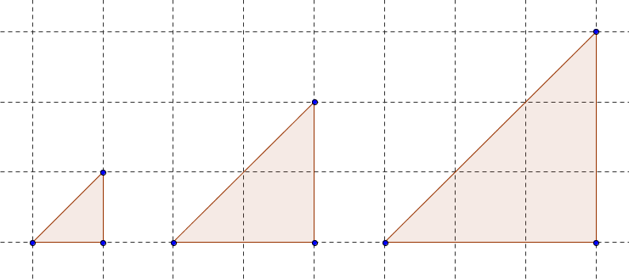

We’re going to give you a book of Platonic Right Triangles. Each triangle in this book is going to represent an ideal form of this right triangle. Now, this book only has 89 right triangles in it. It has triangles like a 25-65-90 triangle, and a 10-80-90 triangle. For now, let’s not worry about triangles like 10.5-79.5-90 and 2.1-87.9-90 triangles, okay? We’ll add them in later!
Every triangle I’m going to show you below is similar to one of the Platonic Right Triangles.
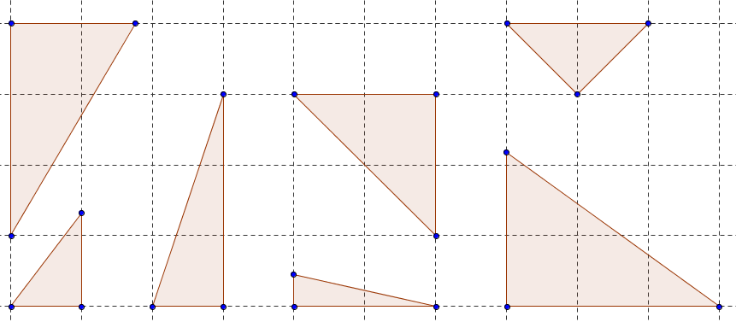
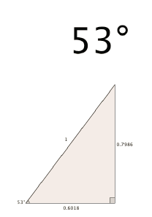
For each triangle above, you’re going to use a protractor to find the corresponding Platonic Right Triangle in the book that corresponds. For example, if the triangle above corresponds to the page on the right, clearly label the 53º angle in the triangle above.

Now you’re going to figure out the side lengths. Use what you know about similarity to do this. Don’t find the side lengths in terms of centimeters or inches – use gridunits. Let one gridunit be the length between gridmarks.
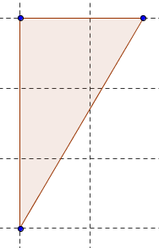 | Find the triangle that is similar to this triangle in the Platonic Right Triangles book. Copy that Platonic Right Triangle here, with all the side lengths and the one angle given. | Use this space to find the length of all three sides of the given triangle. Then label the length of the three sides (to four decimal places) in the diagram.
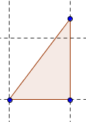
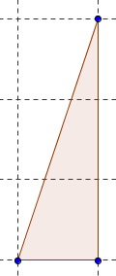
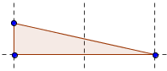
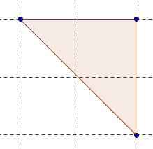
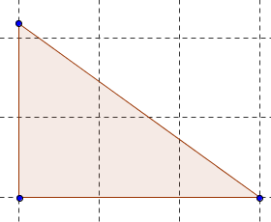
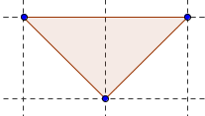
3. Practice: Given the following triangles, use the Platonic Right Triangles book to come up with the missing side length. Have your answer rounded to four decimal places. Show your work.
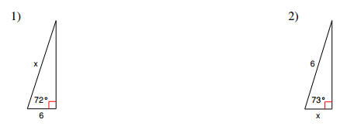

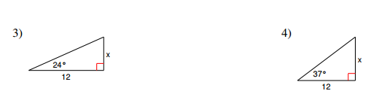
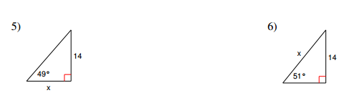

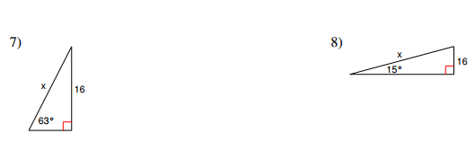

The Chapel
Today we’re going to find the height of the pipe organ at Packer.
In order to do this, your group needs:
- One phone with a clinometers app
- A straw taped to the phone as your eye-piece
- String
- A yardstick
- First, let’s go into the Chapel and have a look around. Write down an estimate the height of the top of the pipe organ is (in feet).

Now each group should have one person stand at a different place in the chapel, and use their clinometers to measure the angle from where they stood to the top of the organ.
- The other two people in the group should measure the distance from the organ to the place where their group member measured the angle – using string. The string should be as horizontal and taut as possible – measured from eye level of the person measuring the angle to the organ itself.
Location 1:
The angle (rounded to the nearest degree): _________ [this is known as the angle of inclination]
The distance (rounded to the nearest inch): _________
Now do this again from two different locations
Location 2:
The angle (rounded to the nearest degree): _________ [this is known as the angle of inclination]
The distance (rounded to the nearest inch): _________
Location 3:
The angle (rounded to the nearest degree): _________ [this is known as the angle of inclination]
The distance (rounded to the nearest inch): _________
Let’s go back to the classroom.
A diagram of what you did:
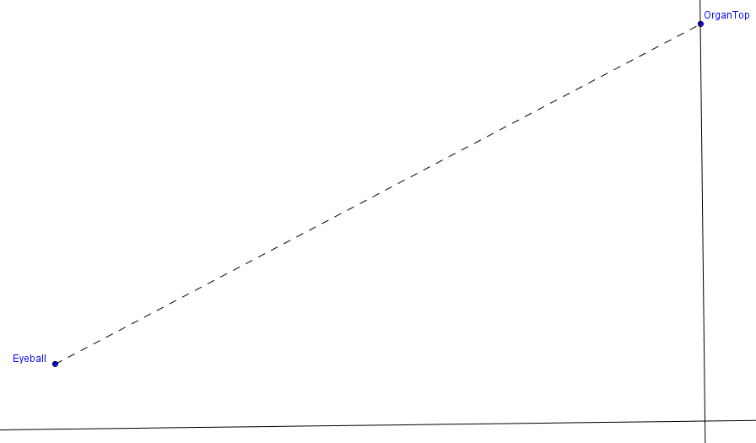
- Use your measurements and the Platonic Right Triangles book in order to find the height of the organ three different times, from your three different sets of measurements. Mark up the diagrams below with the numbers that you measured.
Location 1:
Location 2:
Location 3:
4. It is hard to get an accurate read of the angle using your clinometer. You might have been a few degrees off. Use your data for Location 1. What would the height of the organ be if:
(i) the true angle were 3 degrees smaller than what you recorded? | (ii) the true angle were 1 degrees smaller than what you recorded?
(iii) the true angle were 1 degrees larger than what you recorded? | (iv) the true angle were 3 degrees larger than what you recorded?
5. What if the angle you measured was perfectly accurate, but the distance you measured was off? Use your data for Location 1.What would the height of the organ be if:
(i) the true distance was 3 feet more than what you recorded? | (ii) the true distance was 1 foot more than what you recorded?

From Kuta Software

