Mathematician | Date | Band
Crossed Diagonals (Proof)
Adv Geometry | Packer Collegiate institute

Previously, we conjectured that if we had a cyclic quadrilateral, we saw that (a)(c)=(b)(d).
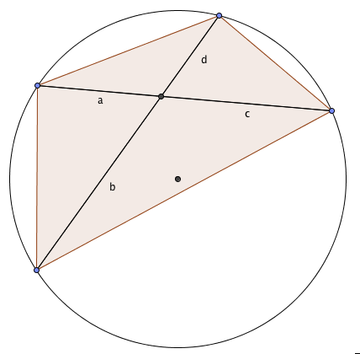
What we want you to do is prove that this is true for any cyclic quadrilateral.
Below we will put a number of different diagrams of cyclic quadrilaterals that you can use to figure your proof out.

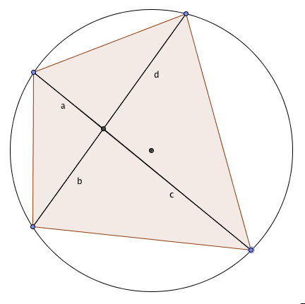

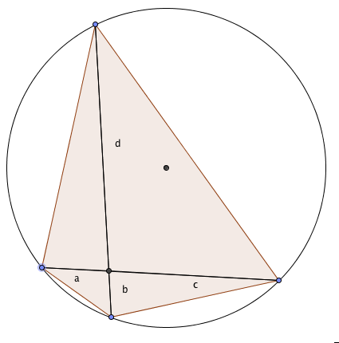

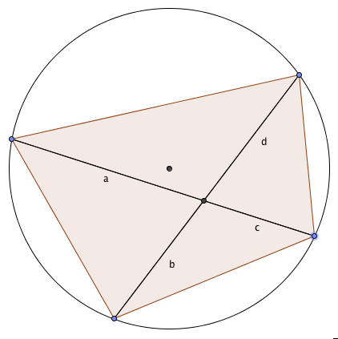

Practice using your proven theorem to find the missing length x:

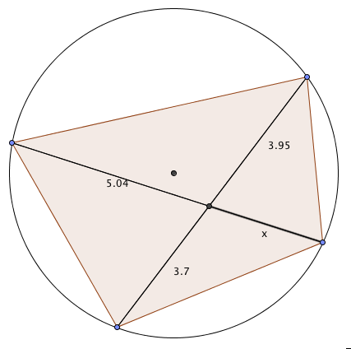 | 1.
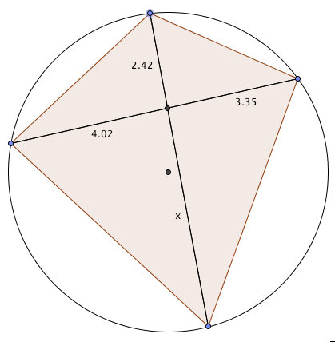 | 2.
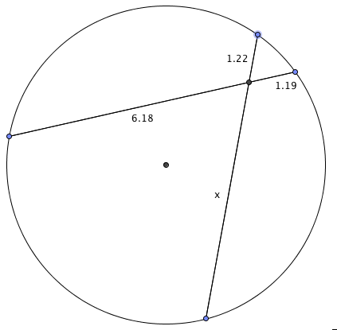 | 3.
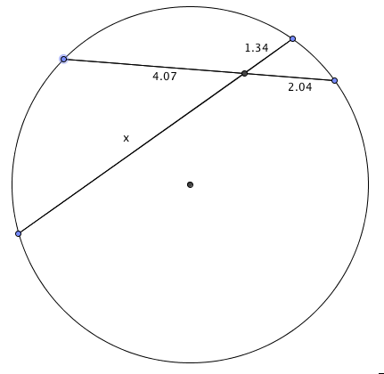 | 4.

