Mathematician | Date | Band
Inscribed Angles Conjecture
Adv Geometry | Packer Collegiate institute

Central Angle  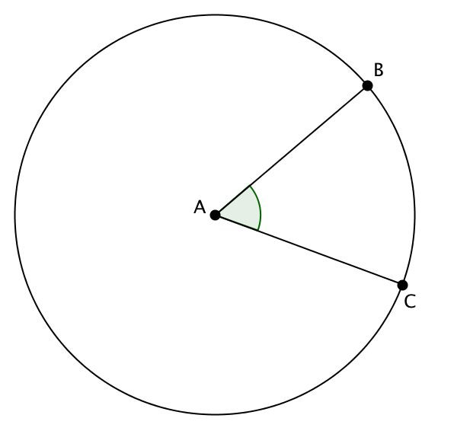 | Inscribed Angle  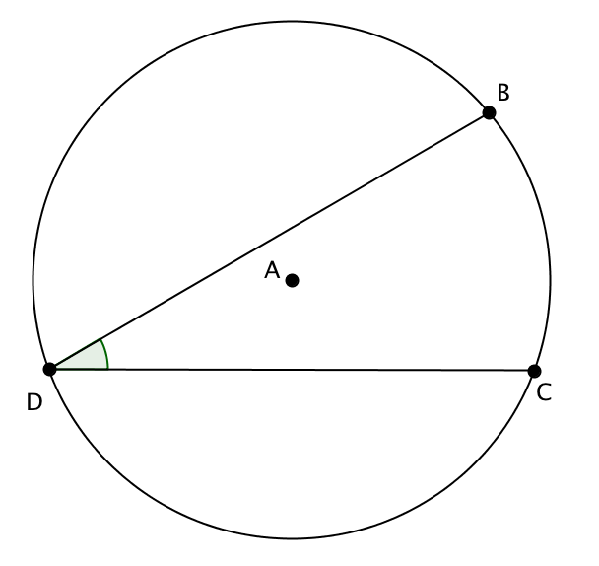 | A central angle is an angle whose vertex is at the center of a circle. In the image, the central angle is subtended by arc BC.  An inscribed angle is an angle whose vertex is on the circle itself. In the image, the inscribed angle is subtended by arc BC.

Directions: Each person in your group will pick a different central angle from the following list:
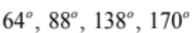
… and draw it in the circle below. Label the subtended arc BC. Then each person will draw an inscribed angle that is also subtended by BC. Measure the inscribed angle with a protractor, and write that angle measure in your diagram. Draw a second, third, fourth, fifth, sixth, seventh, and eighth inscribed angle that is also subtended by BC. Measure all those angles with a protractor, and write those angle measures in your diagram.


Based on your observations, what is a good conjecture involving central angles and inscribed angles: _________
__________________________________________________________________________________________
_________________________________________________________________________________________.
Now try to prove your conjecture!

