Mathematician | Date | Band
Super Crazy Insanely Large Numbers
Precalculus | Packer Collegiate institute
Infinity (symbol: ∞) is an abstract concept describing something without any bound or larger than any number.
1. What is the largest number you can write in the space provided below (remember, infinity isn’t a number):

2. Let’s watch a video about Graham’s Number! [https://www.youtube.com/watch?v=GuigptwlVHo]

3. What was the problem that Graham was working on? It’s related to the problem I’m posing below…

Suppose we draw some number of points, and connect every pair of points by a line. Some lines are blue and some are red. Is it possible to do this so that we don’t end up with a red triangle or a blue triangle?
(a) Try it for four points. I’m giving multiple graphs in case you need them. If you can create a graph without a red or blue triangle, you are done! Then move on to part (b).
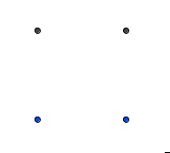
For four points, there are _____ line segments connecting them total. For four points, was it possible to do the coloring so that we didn’t end up with a red triangle or blue triangle? YES / NO
(b) Try this again for six points.

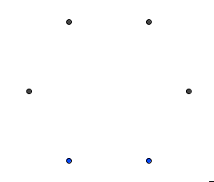

For six points, there are _____ line segments connecting them total. For six points, was it possible to do the coloring so that we didn’t end up with a red triangle or blue triangle? YES / NO

So… it turns out that if you have six or more points, no matter how you color the lines, you’ll always end up with a red triangle or a blue triangle. It’s impossible to avoid having these triangles show up! (However with four or five points, it is possible to avoid all-red or all-blue triangles!) Six points is the magic number of points where we’ll always end up with a triangle of one color.

4. Let’s extend the problem a bit… Let’s go into 3 dimensions!

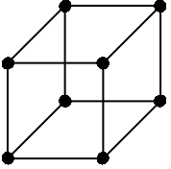
Once again, say we have some points, but now they are the corners of a 3 dimensional cube. They are still all connected by blue and red lines. Is it possible to color these segments so that 4 points that all lie on one plane (and the six lines connecting them) are not all the same color?
WHOA! My brain hurts from this, so let’s break this down a bit…
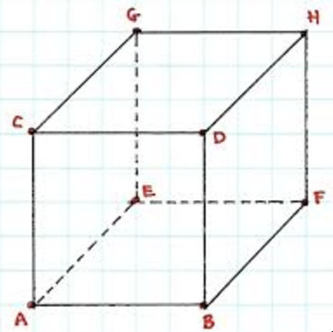
(a) Here is a cube with some of the line segments drawn. Draw in all the other line segments. Make sure that every pair of two points are joined by a line segment.
How many line segments will there be in total? ______
(b) We know that if we pick four points that form a face of a cube, they must lie on a plane. So here’s a harder question:
Can you identify four other points (four points that don’t form a face of the cube) that do lie on a plane? Which points are they?
(c) Can you identify four points that do not lie on a plane? Mark them!

(d) Okay, do me a favor. For one set of four points, draw all the segments required in red. Do the same for the second set of four points, but use blue.
red blue
I’ll call these: “red X in rectangle” and “blue X in rectangle”

(e) Now go to this website and rotate this cube with all the line segments in it. Pretty! But also a bit complicated looking! It should match what you drew in (a).
https://www.geogebra.org/m/RjdQaGz5
(f) Now imagine if you painted each of the line segments red or blue. Here’s the challenge when painting them:
Is it possible to paint the line segments so that for every four points on a plane, we do not end up with a “red X in rectangle” or “blue X in rectange” that you saw in part (d)?

[This is similar to question #2 where you were trying to color the line segments so you did not get an all-red-triangle or an all-blue-triangle. However in this problem we’re trying to not get the things you drew in part (d).]

Now I’m not going to make you do the coloring (you’re welcome!), but look at these two colorings… [look on the SmartBoard to see the colors… I’ll display them.]
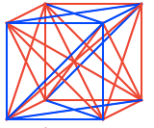  For this coloring:  It turns out there are four points that lie in a plane that form a “red X in rectangle.”  Can you find these four points? | 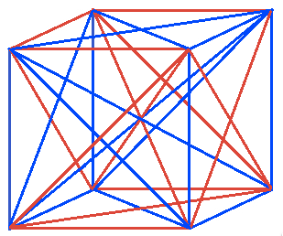  For this coloring:  There are not four points that lie in a plane that form a “red X in rectangle” or “blue X in rectangle.”
(g) Okay, so let’s revisit the question:

Once again, say we have some points, but now they are the corners of a 3 dimensional cube. They are still all connected by blue and red lines. Is it possible to color these segments so that 4 points that all lie on one plane (and the six lines connecting them) are not all the same color?

So the answer is “yes.” That second coloring provided shows it is possible do the painting and avoid drawing the “all red X in rectangle” and “all blue X in rectangle.”

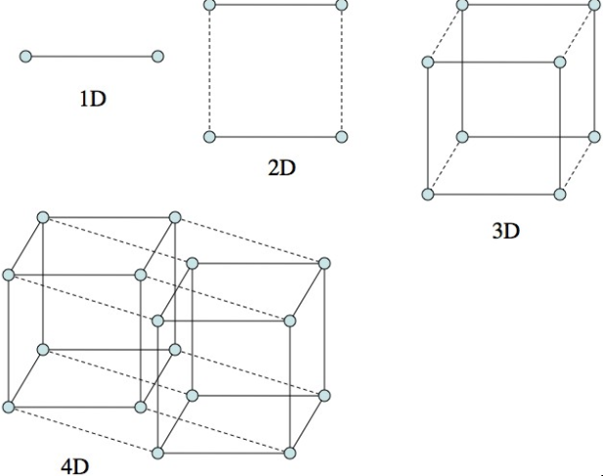
5. What does this have to do with Graham’s number?
Well mathematician Ronald Graham was working on this exact same problem but with n dimensional cubes. Here are cubes of 1D, 2D, 3D, and 4D. He was going up to 5, 6, 7, … dimensions!

The question he was working on:
Once again, say we have some points, but now they are the corners of an n-dimensional cube. They are still all connected by blue and red lines. We know that for any 4 points, there are 6 lines connecting them. Is it possible to color these segments so that 4 points that all lie on one plane (and the six lines connecting them) are not all the same color?
We just saw that for n=3 (a 3-D cube), the answer is “yes.”
What Ronald Graham showed was for n=6 (a 6-dimensional cube), the answer is “yes.” For a 6-D cube, you could carefully color the edges so that you avoid getting the “red X in rectangle” or “blue X in rectangle”! (This is similar to the four points you worked on in #3… You carefully chose your coloring so that you avoided a red or blue triangle.)
However Ronald Graham showed us that for n=”Graham’s Number” (a “Graham’s Number”-dimensional cube) [or any n bigger than “Graham’s Number”], the answer is “no.” In other words, that crazy higher-dimensional cube must have a “red X in rectangle” or “blue X in rectangle” somewhere in it no matter how you painted it – no matter how careful you were to avoid having them appear. (This is similar to the six points you worked on in #3… No matter how you colored them, you were forced to eventually create a red or blue triangle in it!)
Mathematicians know that for n=4, n=5, and n=6, the answer is “yes.” And for n=”Graham’s Number,” the answer is “no.” But for which n do we switch from “yes” to “no”? At this point, no one knows! What Graham did was show us that there was a place where this switch happened – that eventually we’d be forced to have a “red X in rectangle” or “blue X in rectangle.”

