The number 7

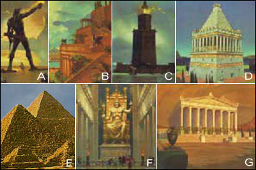  Seven wonders of the ancient world |   The answer is 7. Ask “does anyone know a website that can solve all sorts of equations for you?” If no one knows, encourage kids to google “wolfram alpha.”  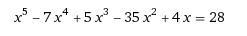
Creates the numeral 7 in desmos.  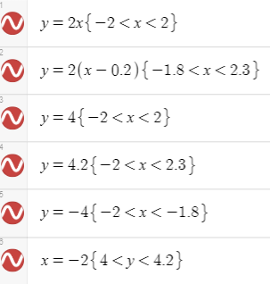 | 1=1^2+0^2+0^2; 2=1^2+1^2+0^2; 3=1^2+1^2+1^2; 4=2^2+0^2+0^2; 5=1^2+2^2+0^2; 6=2^2+1^2+1^2; 7=???  The smallest natural number that cannot be represented as the sum of squares of three integers

The alphabet

Goes to a desmos page with the alphabet written out.  https://www.desmos.com/calculator/l8u2vigxyb | The digits arranged in alphabetical order. E(ight), Fi(ve), Fo(ur), N(ine), O(ne)… You will definitely need to give hints for this. I say “this actually isn’t about numbers but about words.”  8549176320
The word “alphabet” written in braille. Most kids don’t immediately see this as braille, so you need to hold it up and ask the whole class “who thinks they know what this is?” Many say dominos, but someone eventually says braille.  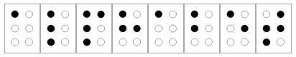 | This is the stock for GOOGL, which isn’t actually GOOGLE anymore. This is the stock for the company “ALPHABET” (which google is just one part of the conglomerate). Ask kids what they think is covered up. They don’t know. So then say “it’s the company name.” If no one in the class knows, I then let kids use their laptops to help.  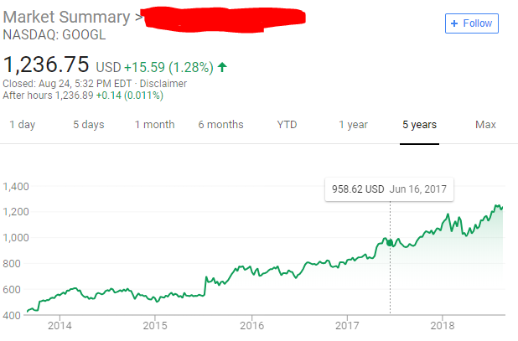

Pi(e)

Circumference over Diameter. AKA pi!   | 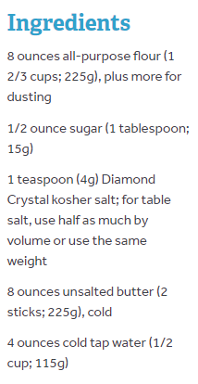  Recipe for pie crust.
A formula for pi. When you type out a bunch of terms in a calculator, you get to around 3.2. So when someone says “pi” for their card, it suggests that this might be pi. I confirm when they get to that point.  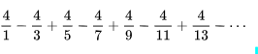 | This is the world record holder for memorized digits of pi.  Rajveer Meena (India) at the VIT University, Vellore, India, on 21 March 2015

The number 10

This is 10!  The number of seconds in 6 weeks is the factorial of this number.  (If you don’t know: 5 factorial is written 5! and means 5*4*3*2*1) | When typed in Desmos, this draws/graphs the numerals “1 0”  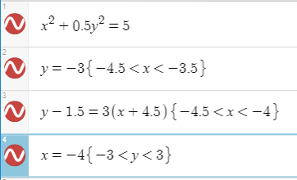
The 10th atomic element.   | The roman numeral for 10.  X

The number 41

The _____ Sophie Germain Prime  (______ is the fourth prime number)  Seven is the fourth prime number, and 41 is the seventh Sophie Germain Prime. They need to use their laptops for this! | 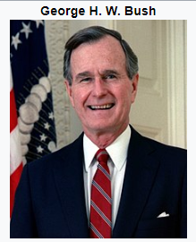  The 41st president
From the Hitchhiker’s Guide to the Galaxy. 42-1=41.  It is one less than the ultimate answer to life, the universe, and absolutely everything. | The solution is 41.  