The number 7

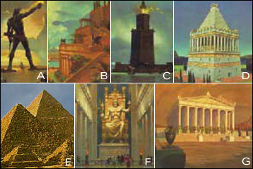 |   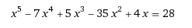
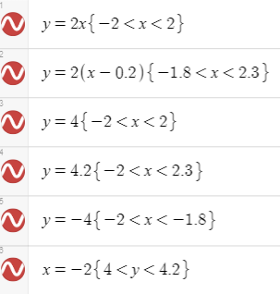 | The smallest natural number that cannot be represented as the sum of squares of three integers

The alphabet

https://www.desmos.com/calculator/l8u2vigxyb | 8549176320
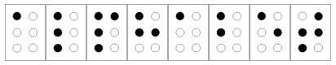 | 

Pi(e)

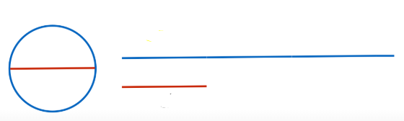 | 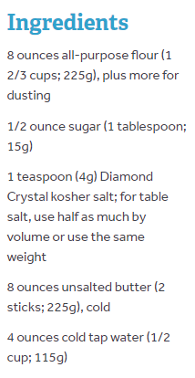
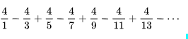 | Rajveer Meena (India) at the VIT University, Vellore, India, on 21 March 2015

The number 10

The number of seconds in 6 weeks is the factorial of this number.  (If you don’t know: 5 factorial is written 5! and means 5*4*3*2*1) | 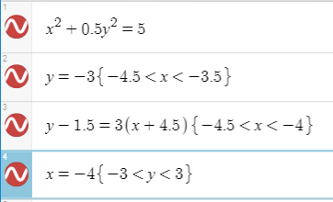
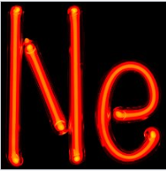 | X

The number 41

The _____ Sophie Germain Prime  (______ is the fourth prime number) | 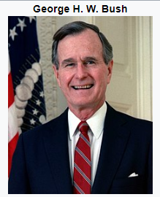
It is one less than the ultimate answer to life, the universe, and absolutely everything. | 